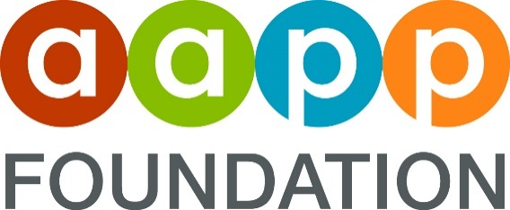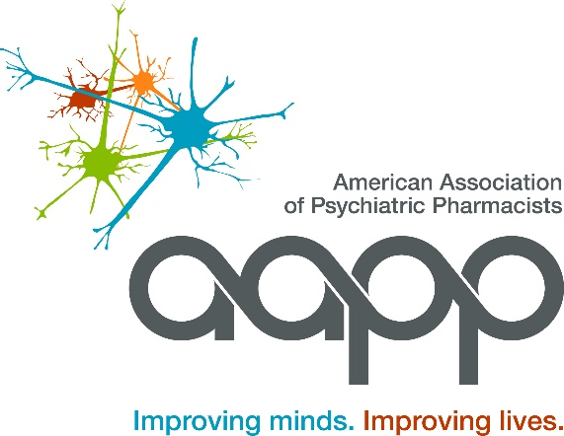

STUDENT REGISTRATION GRANT PROGRAM
2026 AAPP ANNUAL MEETING
April 19-22, 2026 | Bellevue, WA, on Seattle’s Eastside
Please submit Letter of Recommendation to kbrase@aapp.org
Application Deadline: January 15, 2026 ● Selection Notification: By February 6, 2026

Letter of Recommendation Template

Student’s Name:

Recommended by:

- I have known this student for approximately months

- Please describe the capacity in which you have worked with this student (i.e. required course, elective course, student chapter/organization, research project, IPPE rotation, APPE rotation, etc.) Max = 100 words

- Please detail why this student wishes to attend the AAPP Annual Meeting (may include how this student will make use of their time, why they are a good candidate to receive this award, etc.) Max = 200 words

- Please check one of the following boxes as it pertains to your recommendation of this applicant:
☐ Strongly recommend ☐ Recommend without reservation ☐Recommend with reservations

